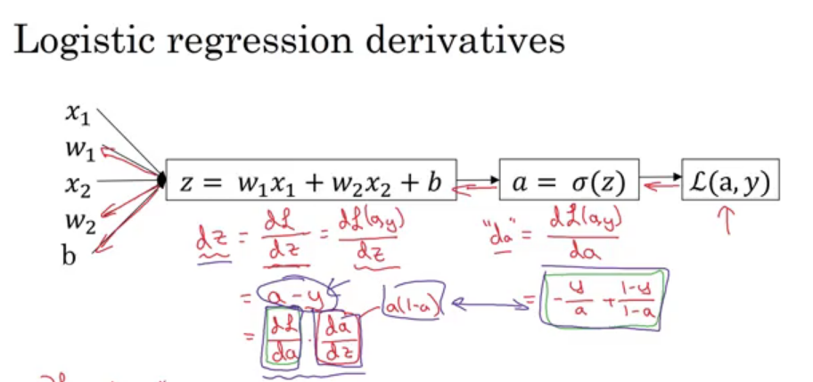

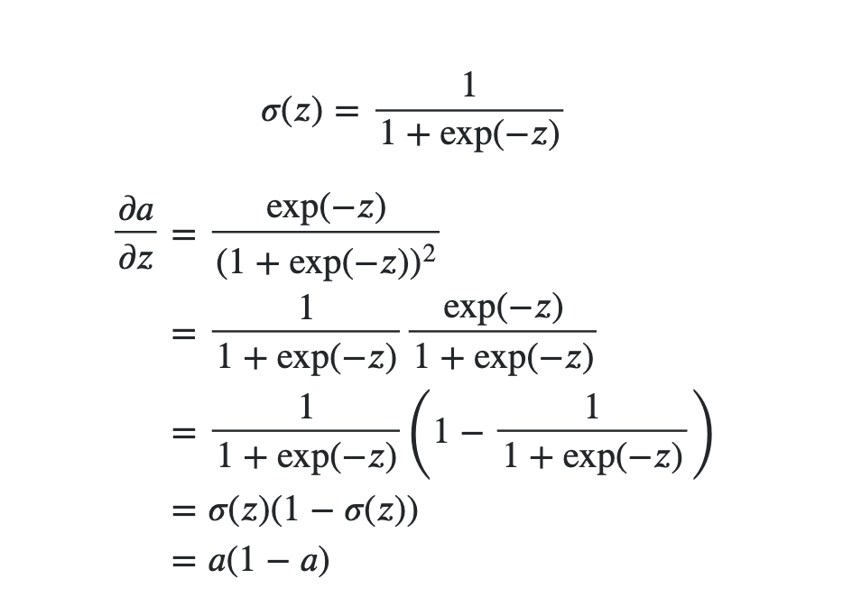

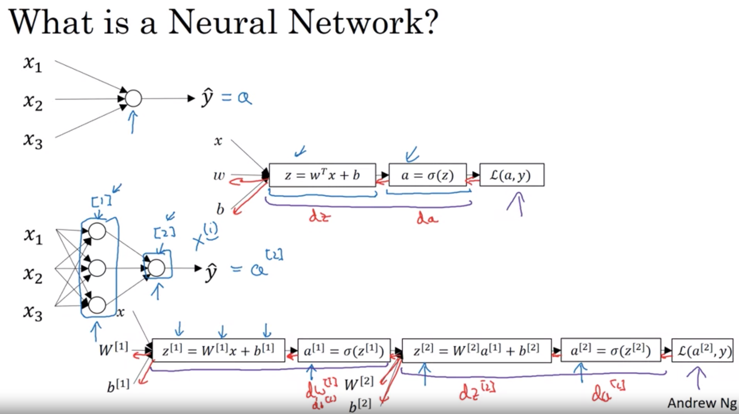

Neural network representation

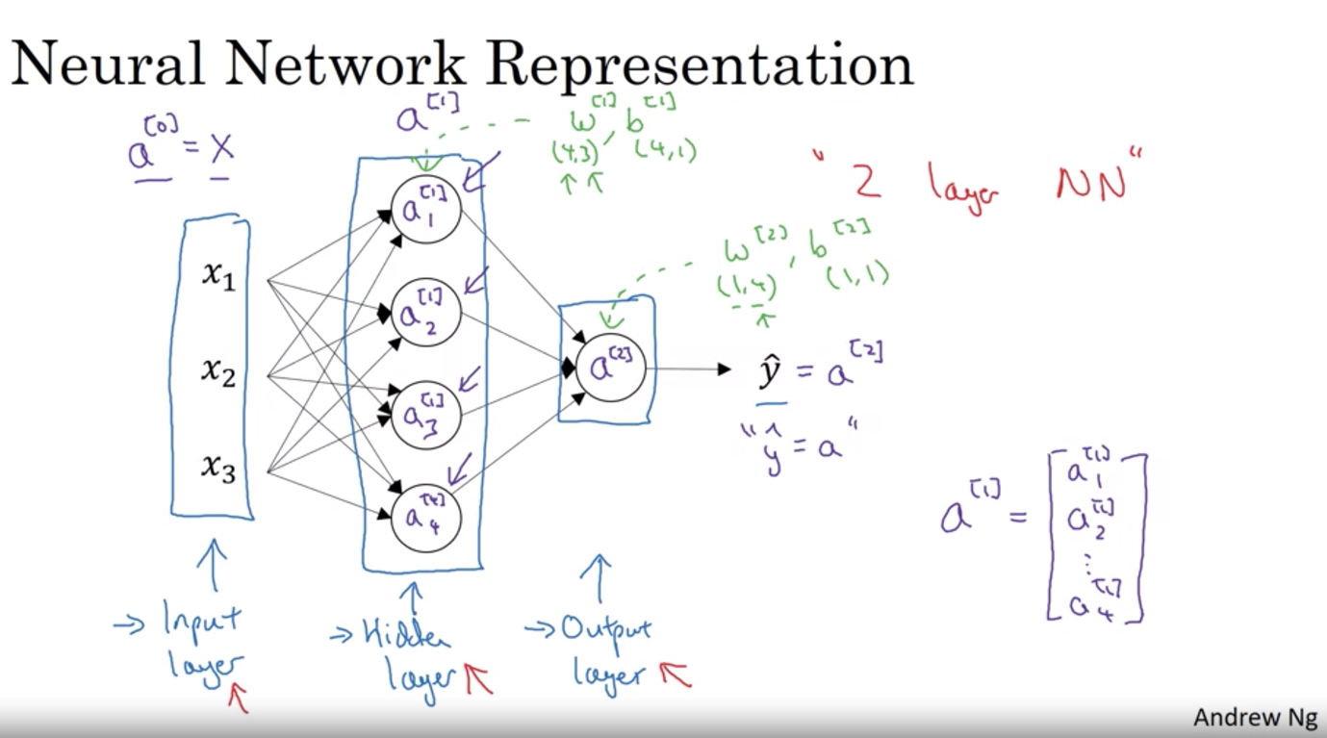

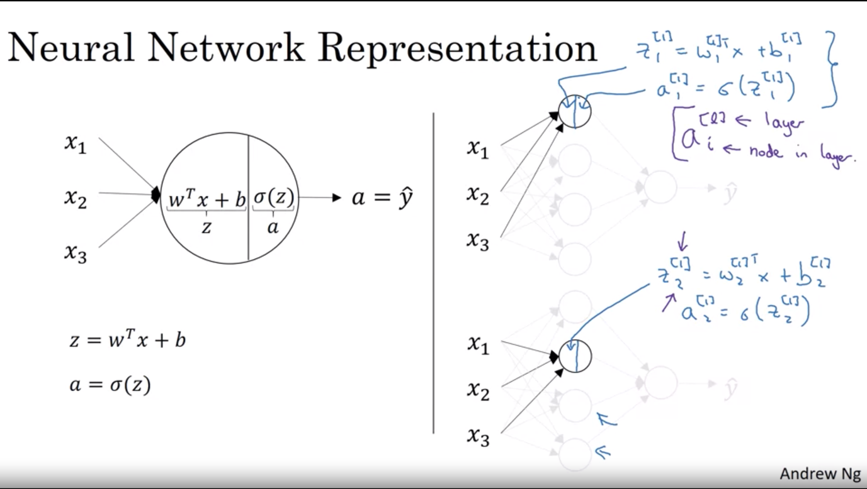

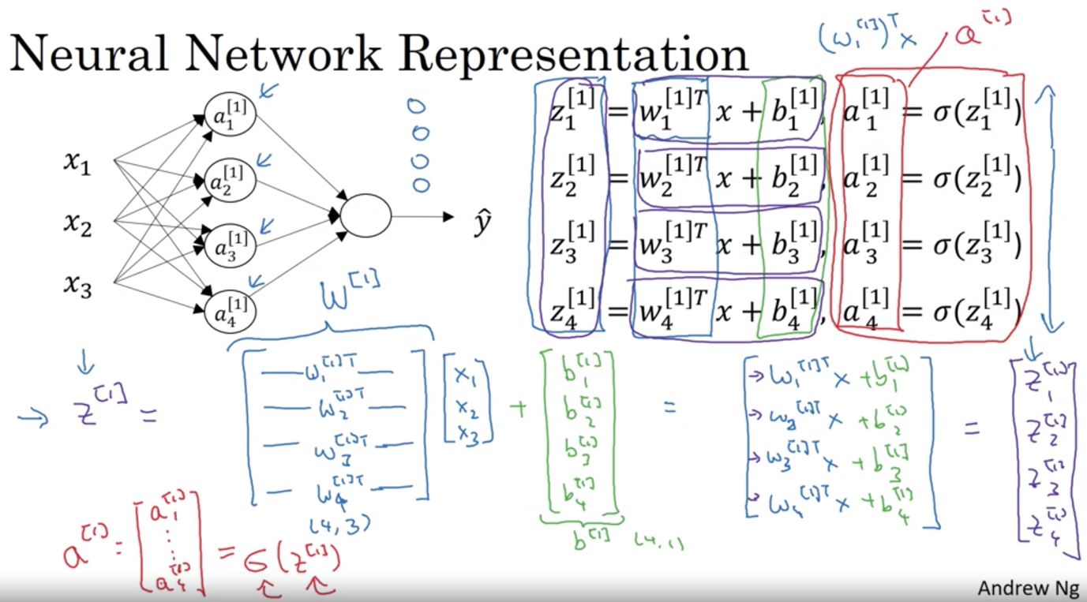

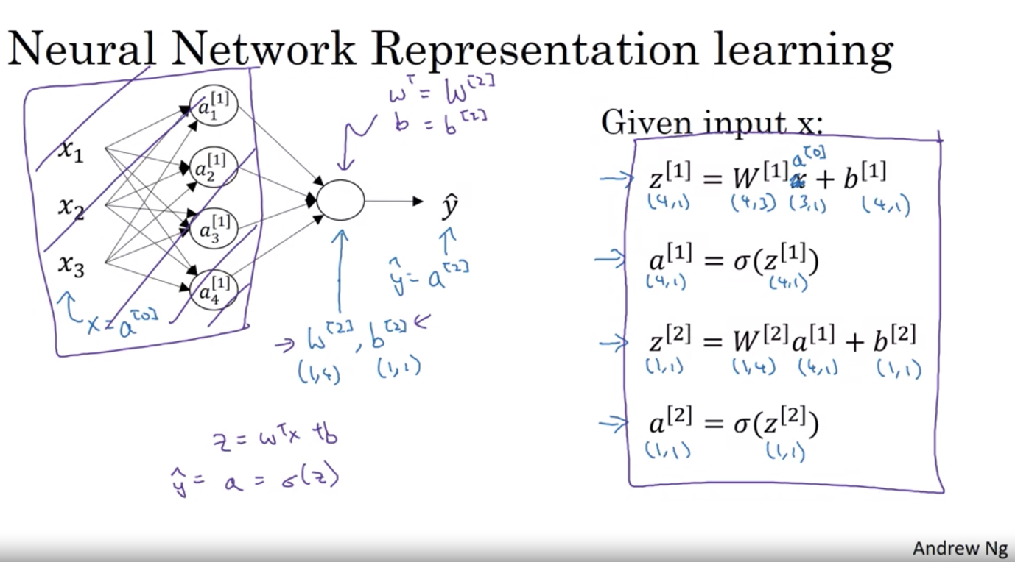

Vectorize across multiple examples

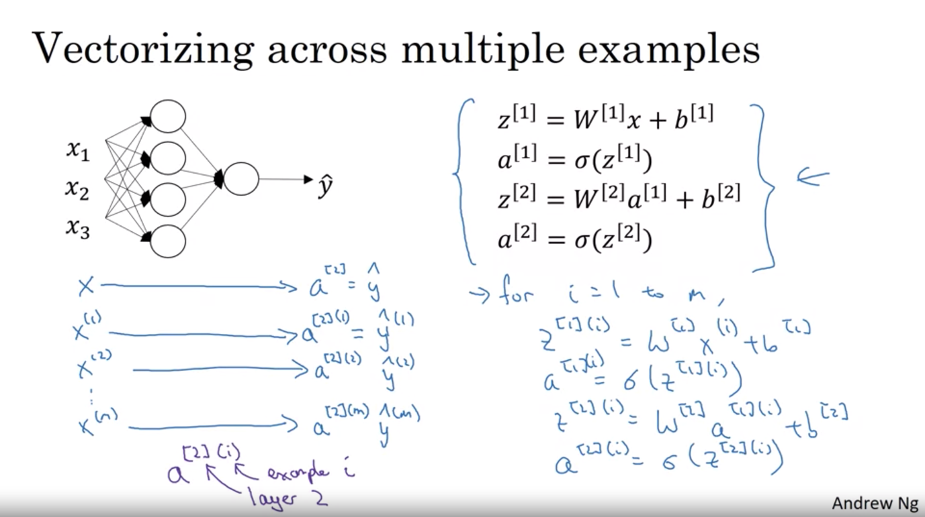

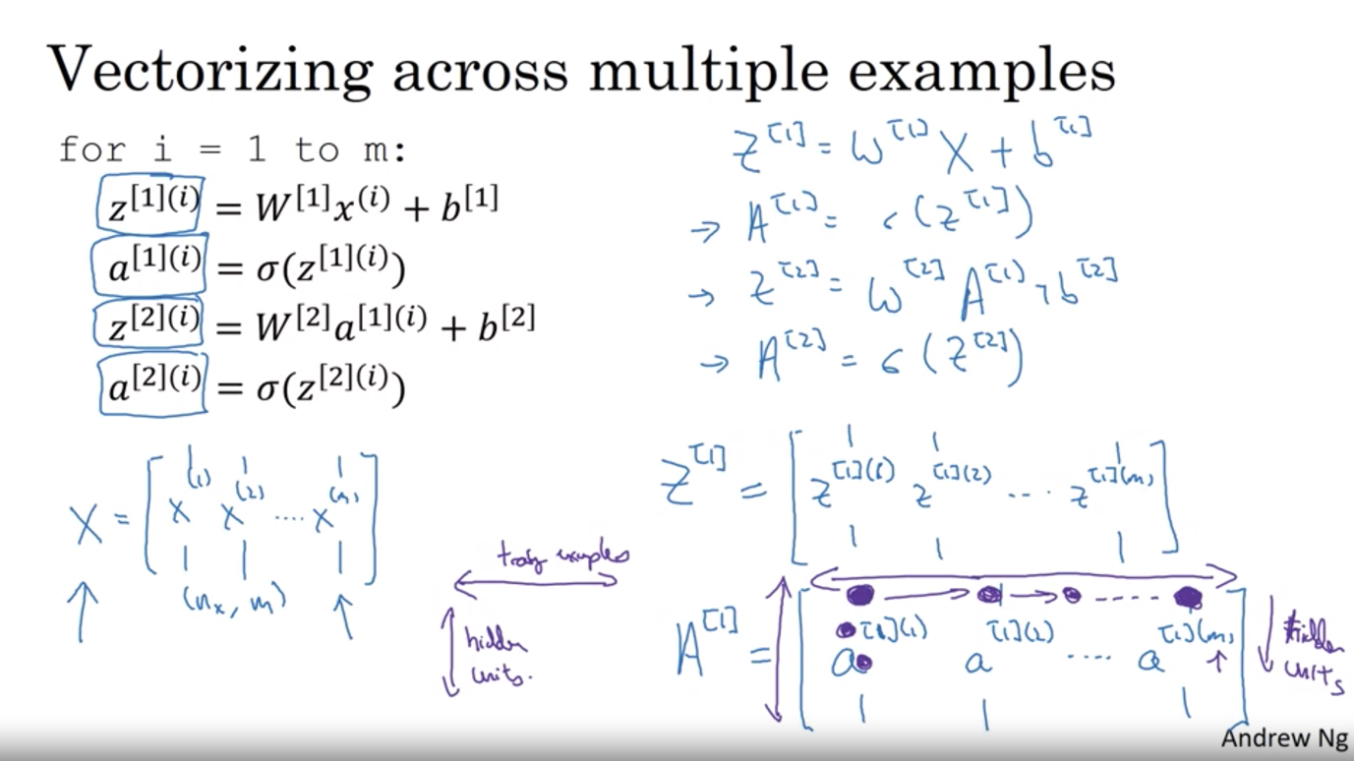

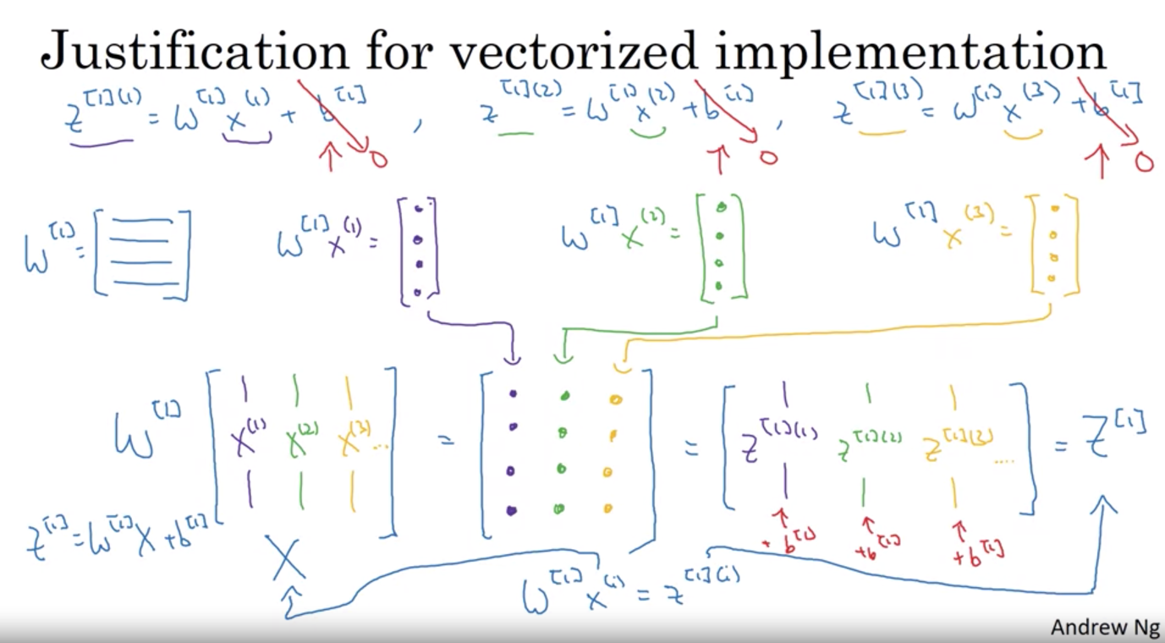

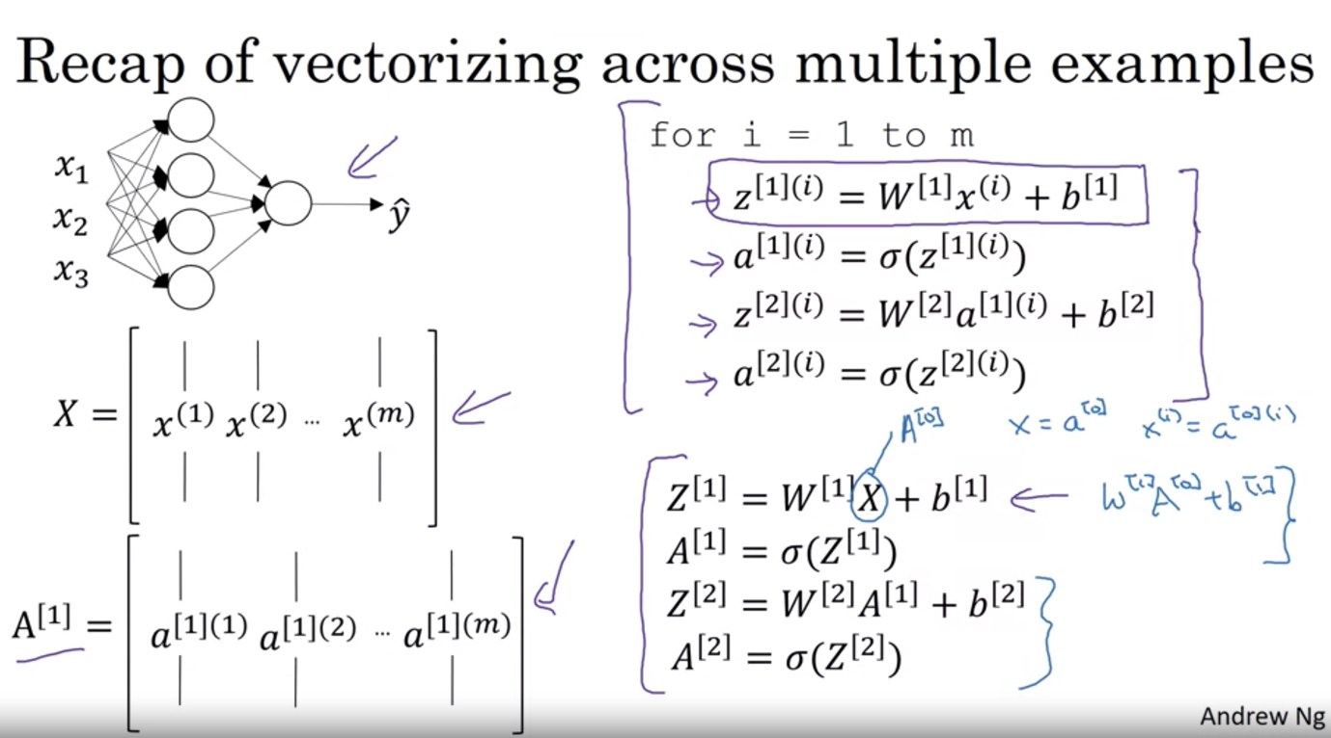

Activation function

Tanh: -1 <= yhat <= 1

Sigmoid: 0 <= yhat <= 1 => good for binary classification

* Problem with both: if z is sufficiently large or small, then the gradient/derivative of the slope of this function becomes very small => slow down gradient descent
* Rectifier Linear Unit: ReLu
* Binary classification (output is 0 and 1): sigmoid for output, all other units: ReLu for the activation function of hidden units
* Disadvantage of ReLU: derivative = 0 when z is negative => leaky ReLU takes a slight dip (though not usually used)
* Advantage of ReLu: much faster than sigmoid and tanh as it does not have much derivative in 0 (most of range of z is positive)

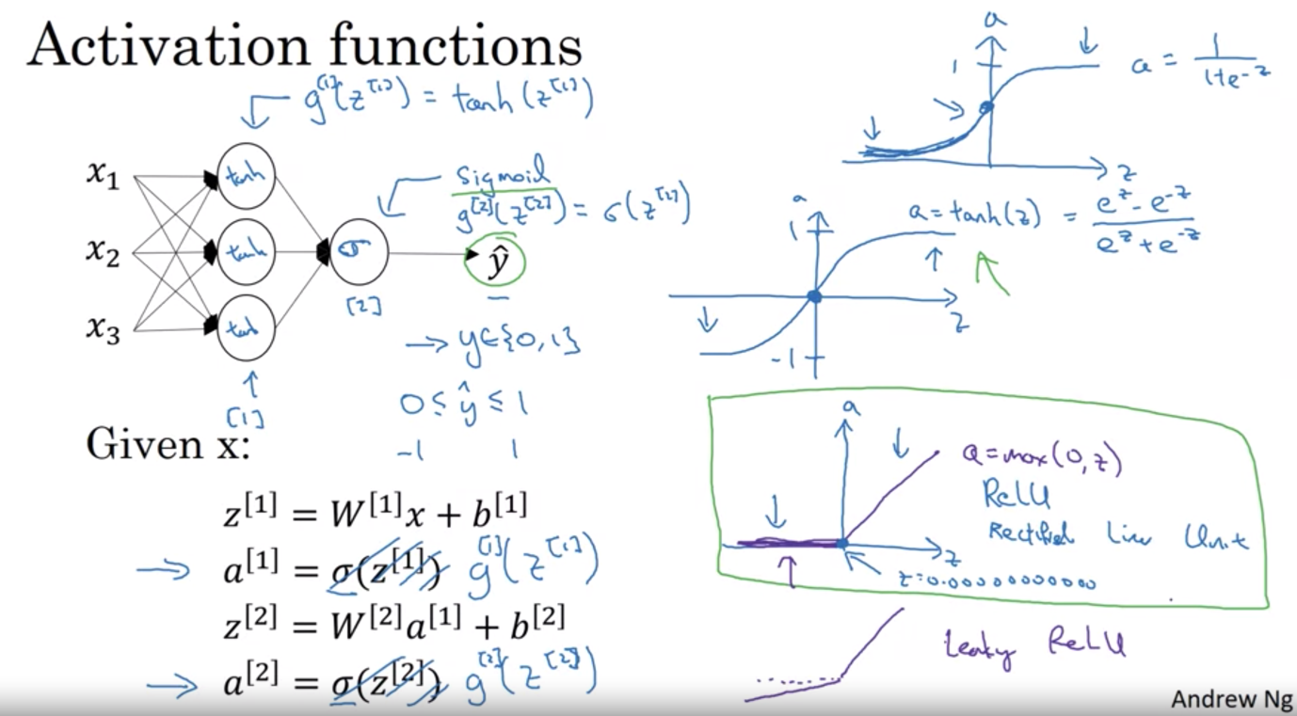

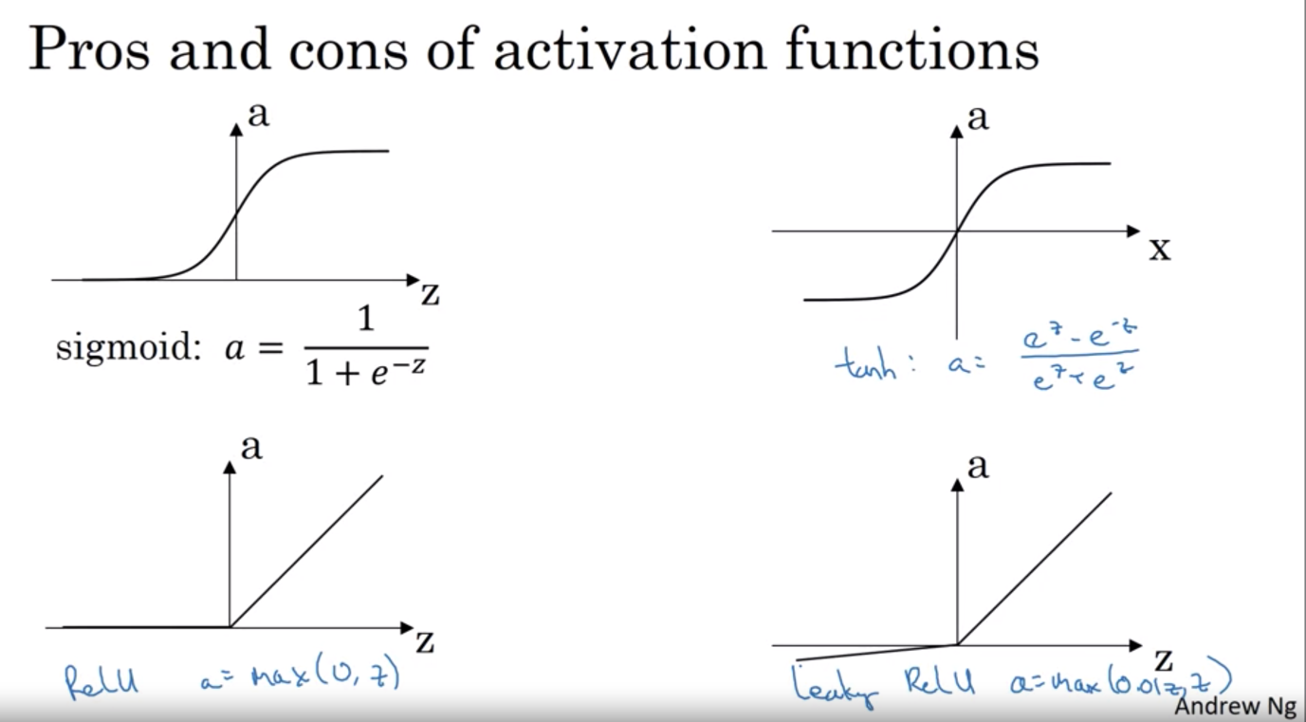

Why non linear activation function ?

If use linear activation function => your output is always a linear expression of input => not much insight there, exception for regression problem (predict housing prices) => use linear activation function in the output layer and ReLU in the hidden layer

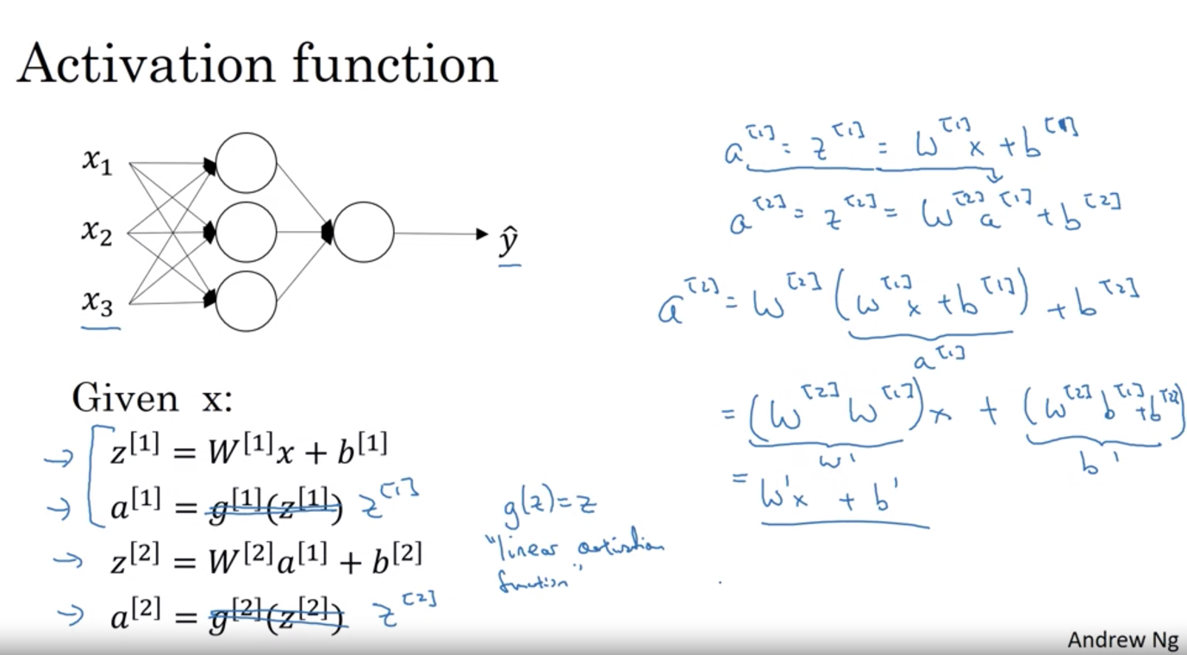

Derivatives of activation function

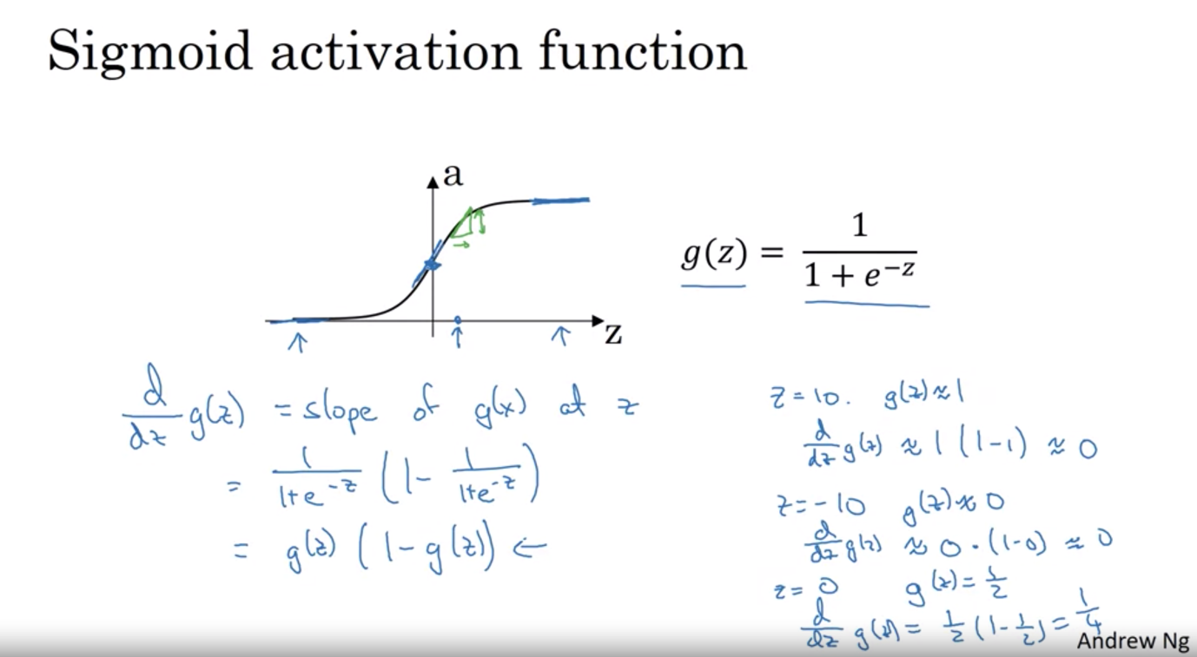

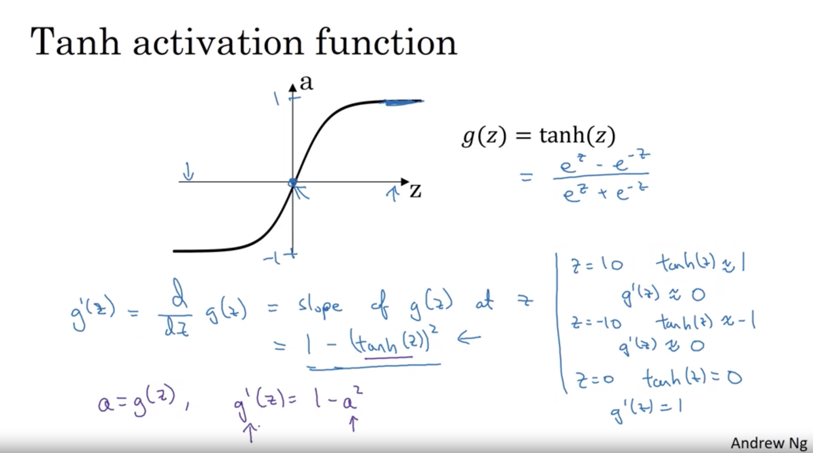

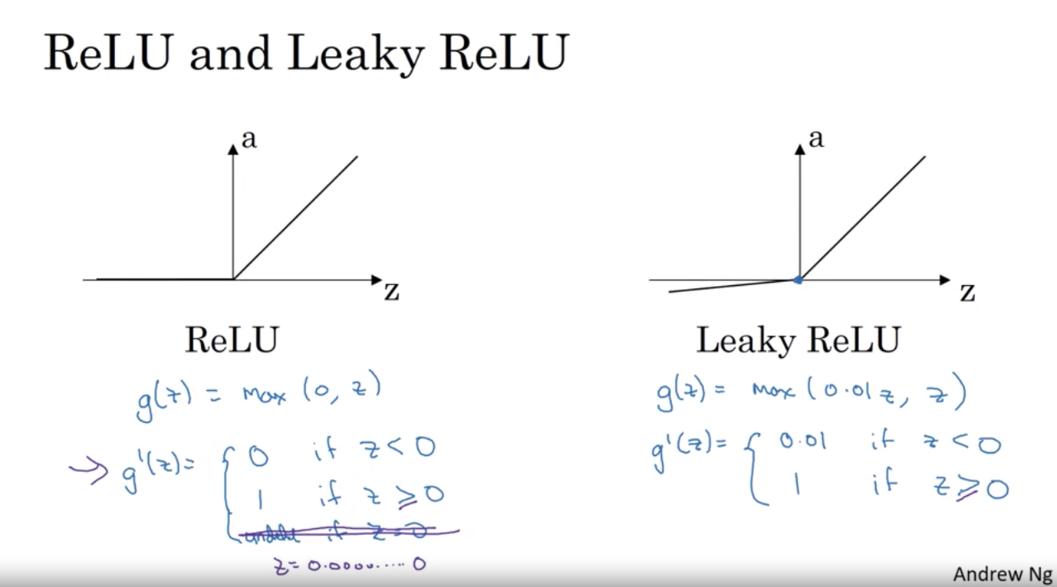

Gradient descent

Repeat until convergence

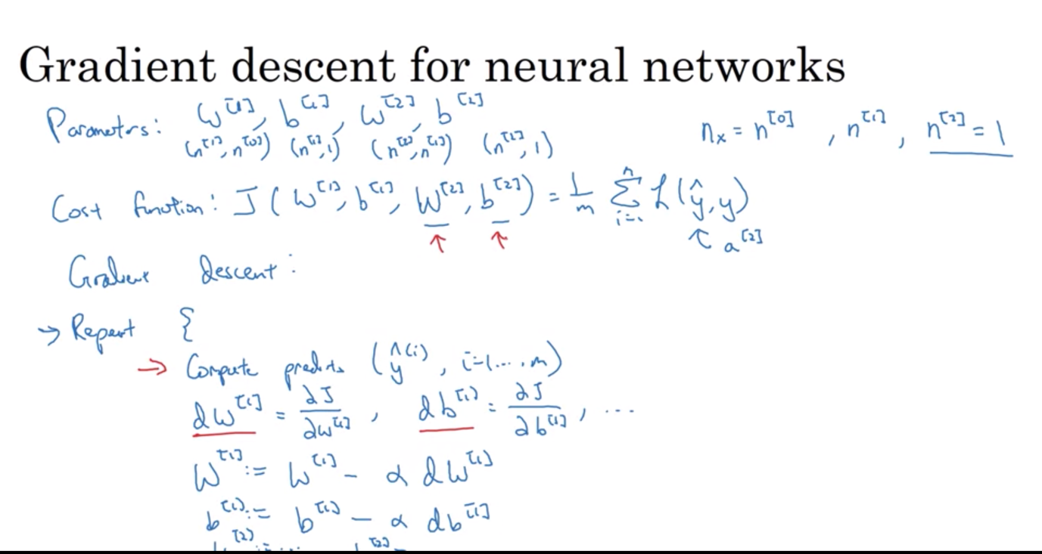

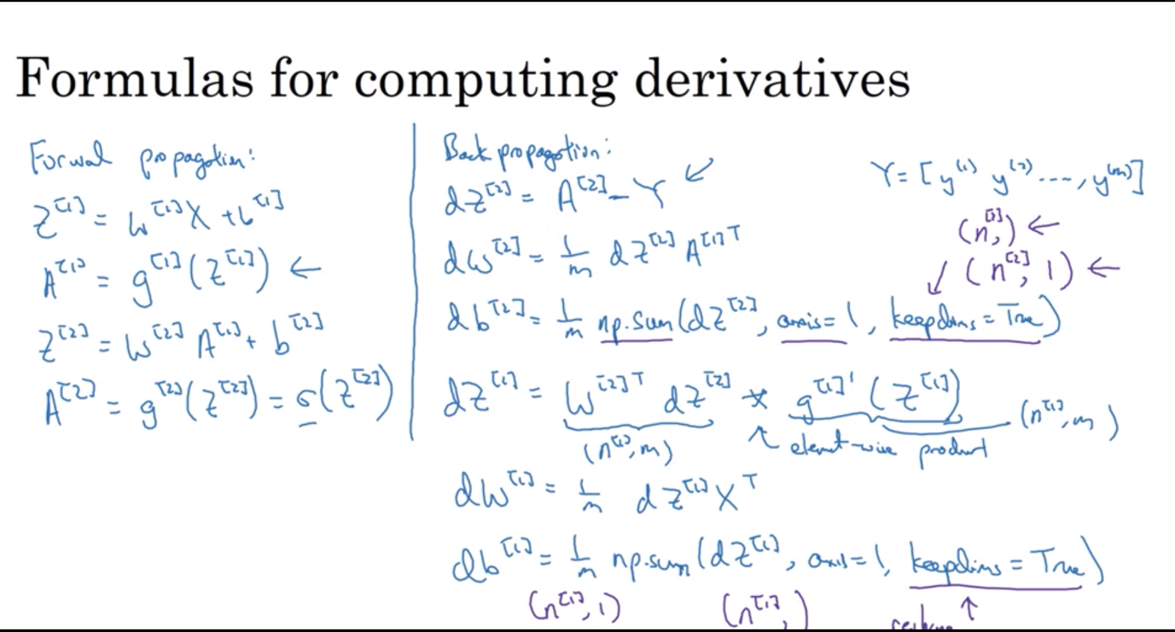

Back propagation intuition:

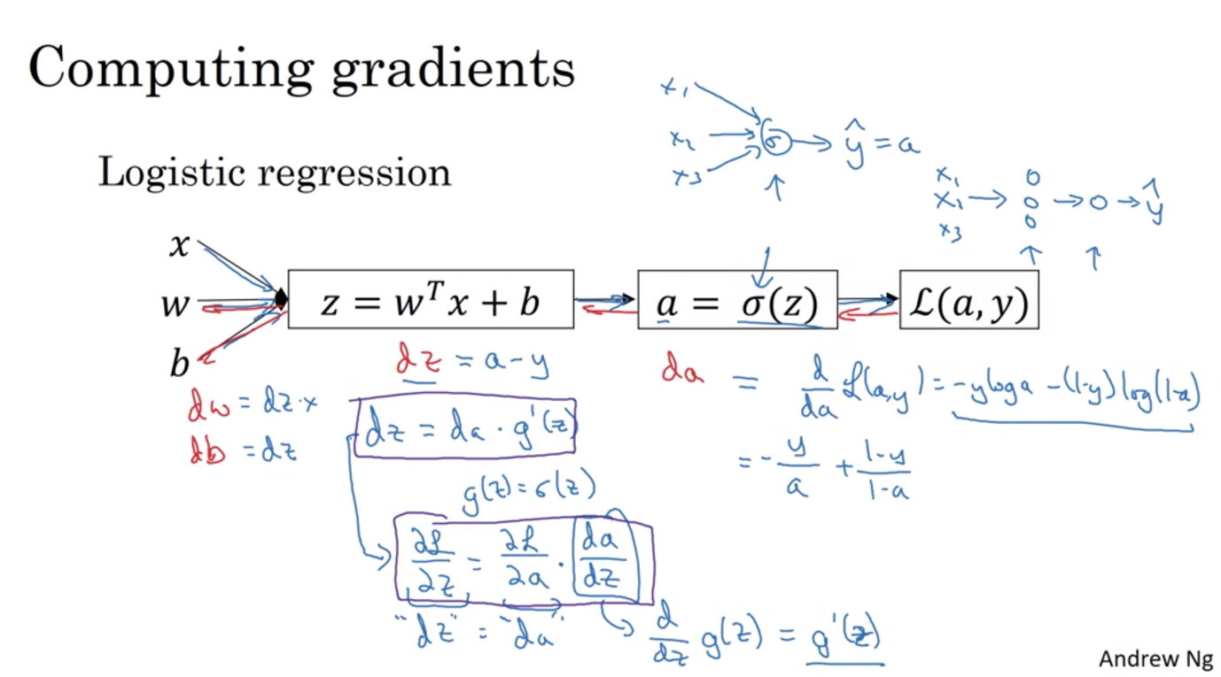

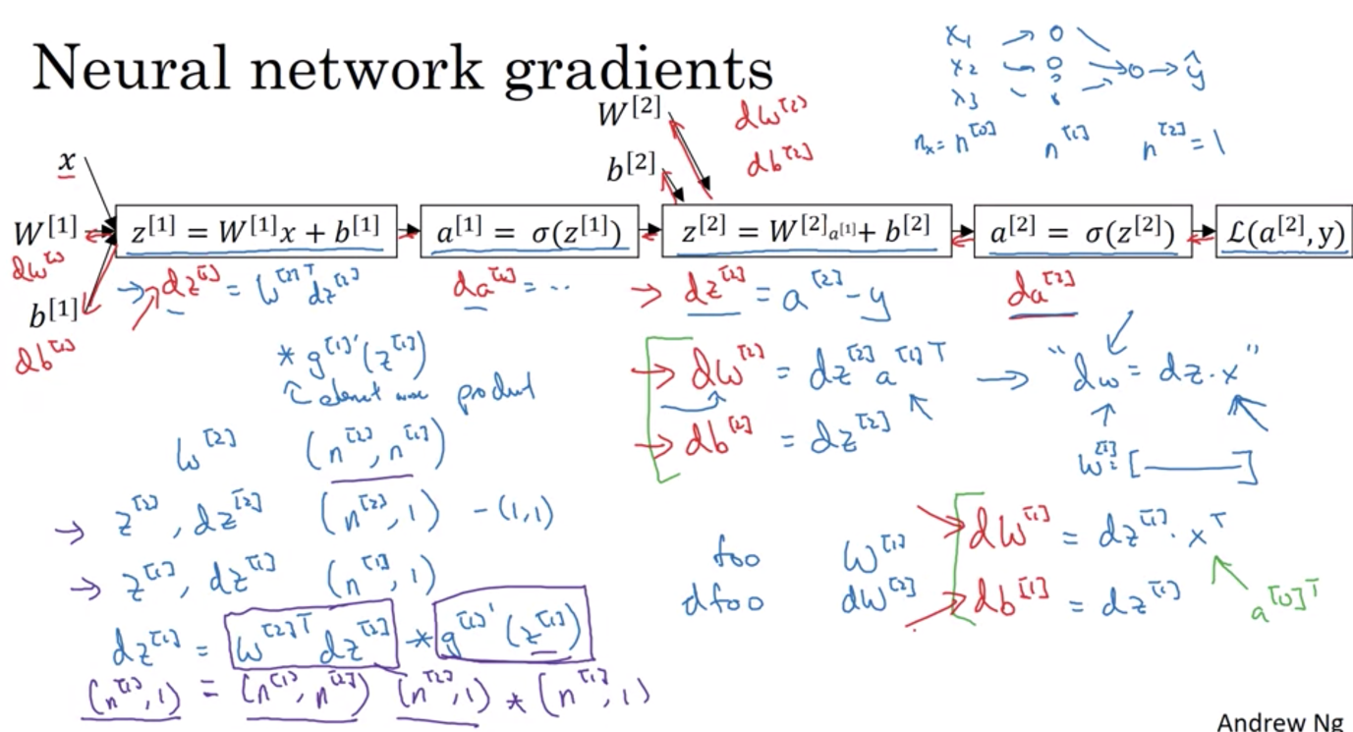

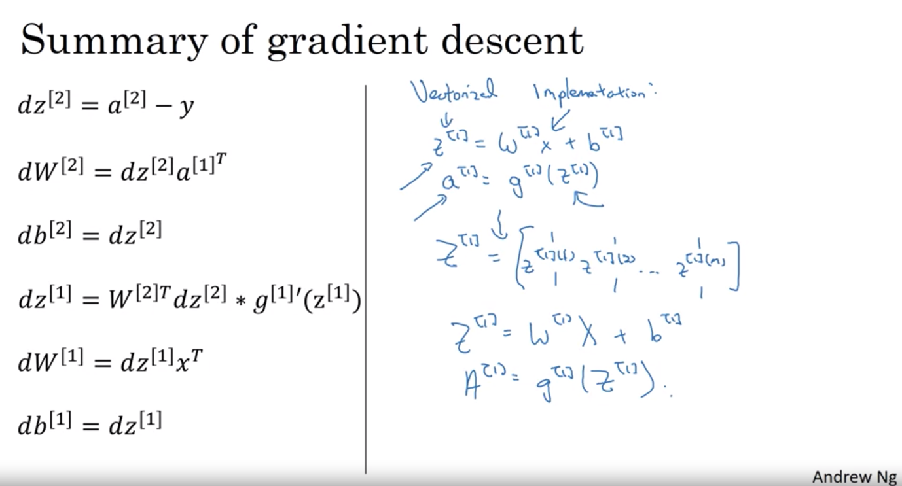

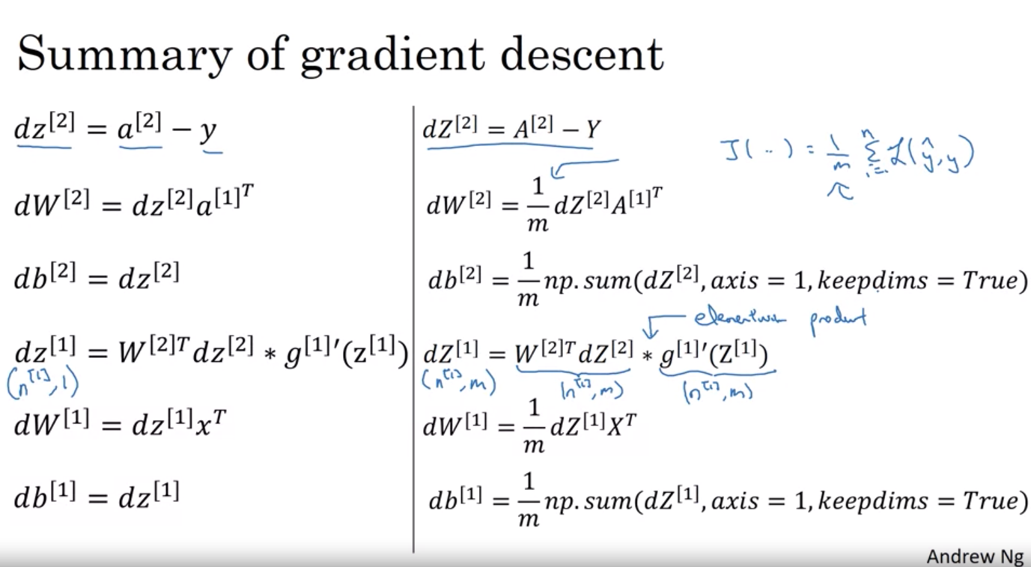

Random Initialization

If initialized to 0 => all the layers computing the same function

* Solution: set at random w \* a very small random value (like 0.01), b doesn’t have symmetry problem and therefore can be set to 0
* Why small random value: if the weight is very large, for sigmoid activation function for example, z becomes very large => lies on the two flat line where the slope of gradient descent is very small => learning is slow
* For shallow neural network (1 hidden layer), 0.01 might be an ok number, but for deeper neural network, a different constant might be needed.

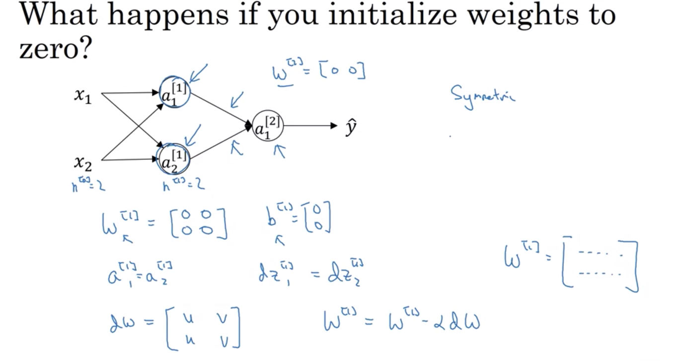

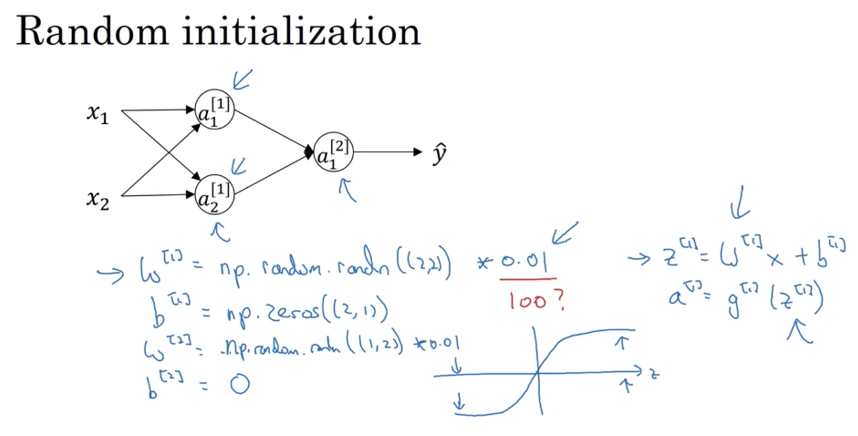

Week 4: Deep Neural Network

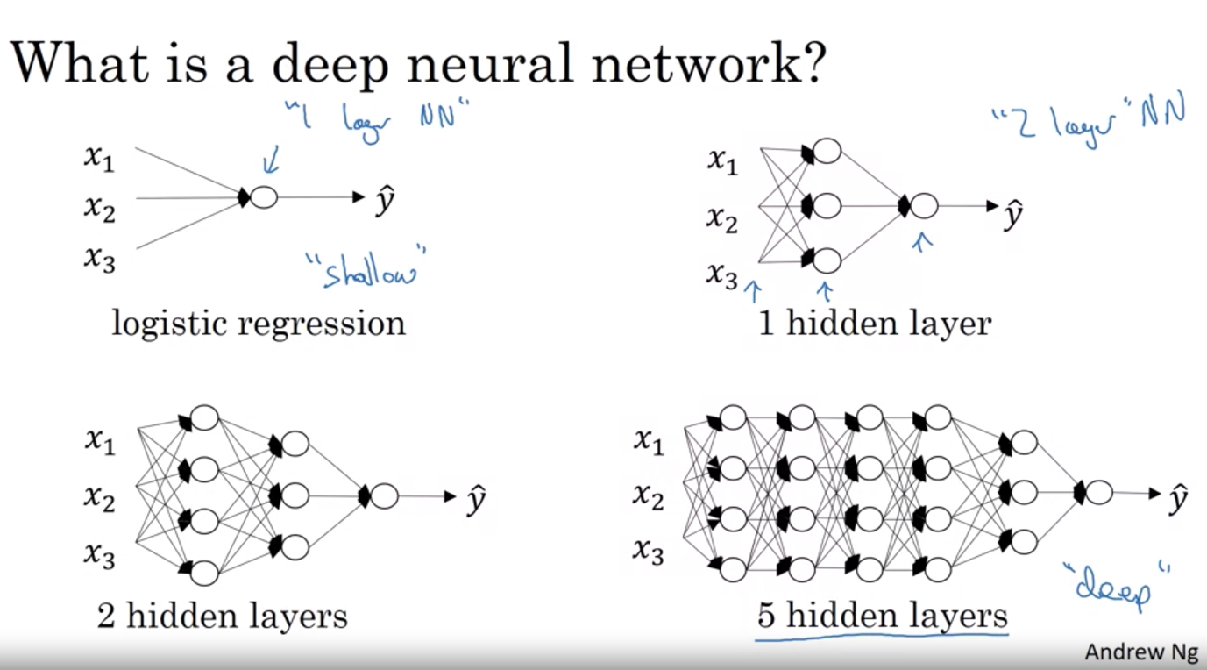

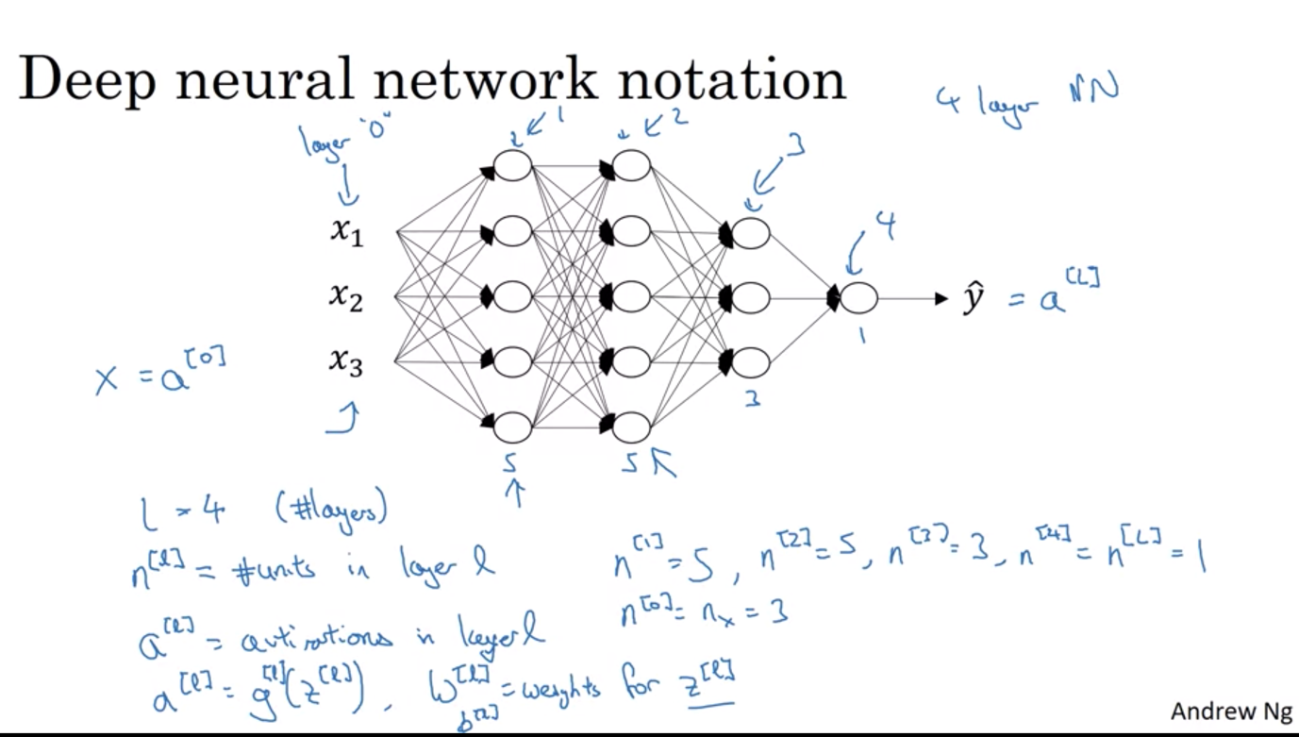

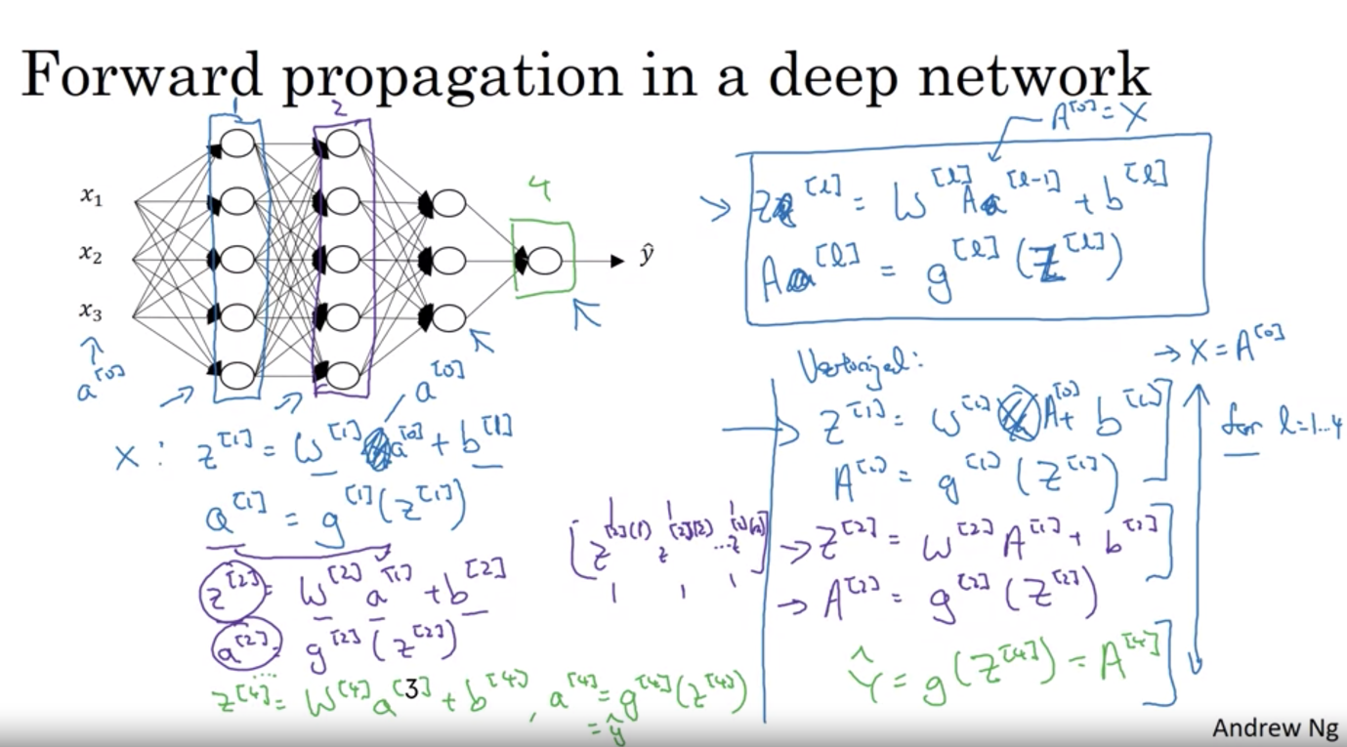

Getting the right matrix dimension

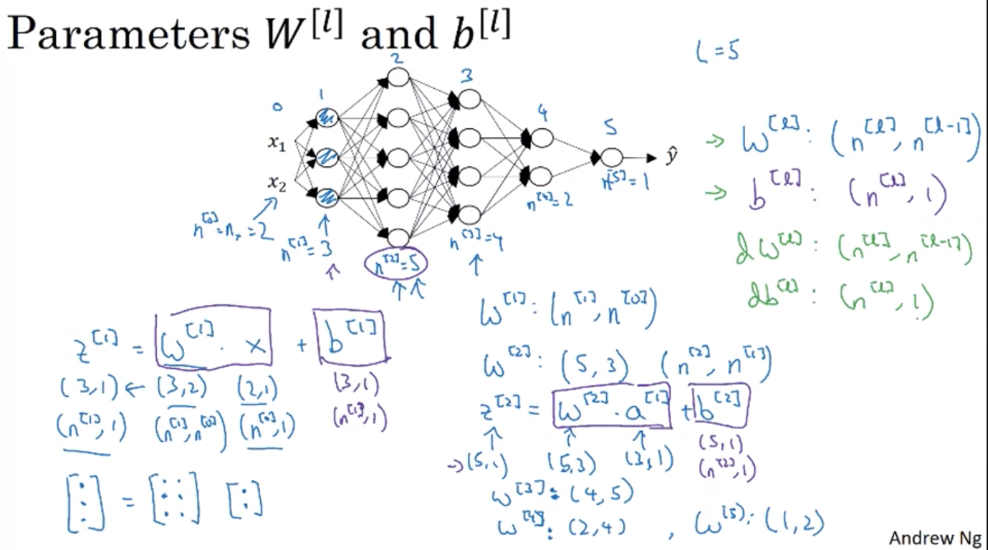

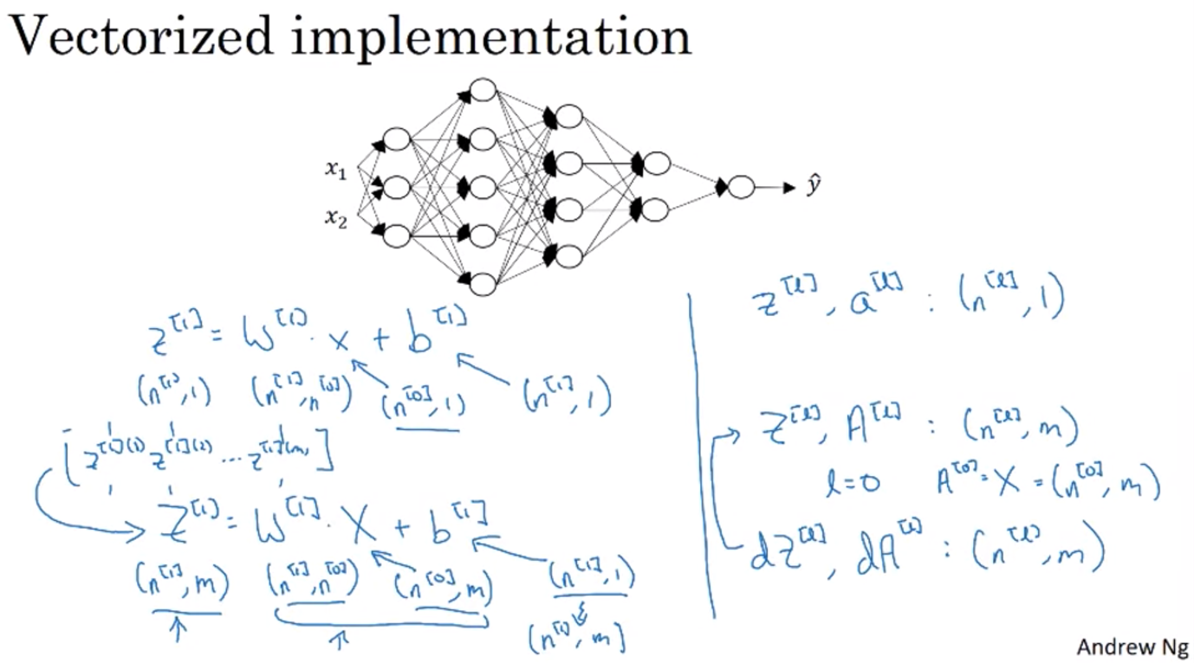

Why deep neural net works?

Intuition about deep neural networks:

* For image classification: 1st hidden layer might be something like edge detection; 2nd hidden layer might add the edges together to detect certain features of the face => put together lots of edges can detect different parts of the face => 3rd layer might put all these different parts together to detect different types of faces
* Earlier layer look at smaller area of the image, have smaller functions => composing together to make more complex things
* This type of simple to complex hierarchical representation also appear in other types of data, not just face recognition and image classification
* Ex: audio recognition: 1st layer recognize low level audio waveform (white noise,etc.) => 2nd basic unit of sound => 3rd words, audio => 4th phrases, sentences

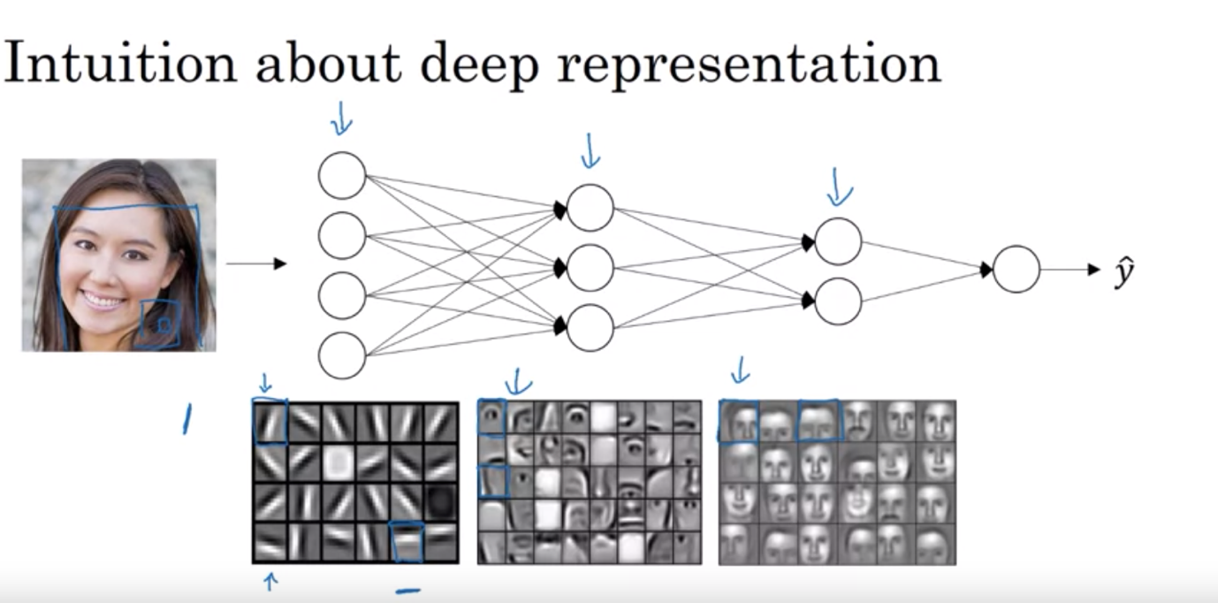

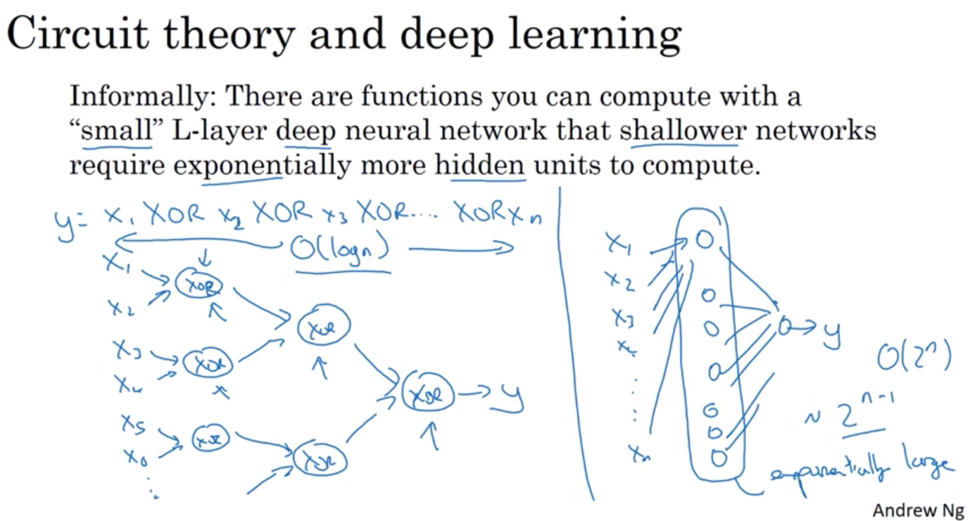

Building blocks of deep neural networks

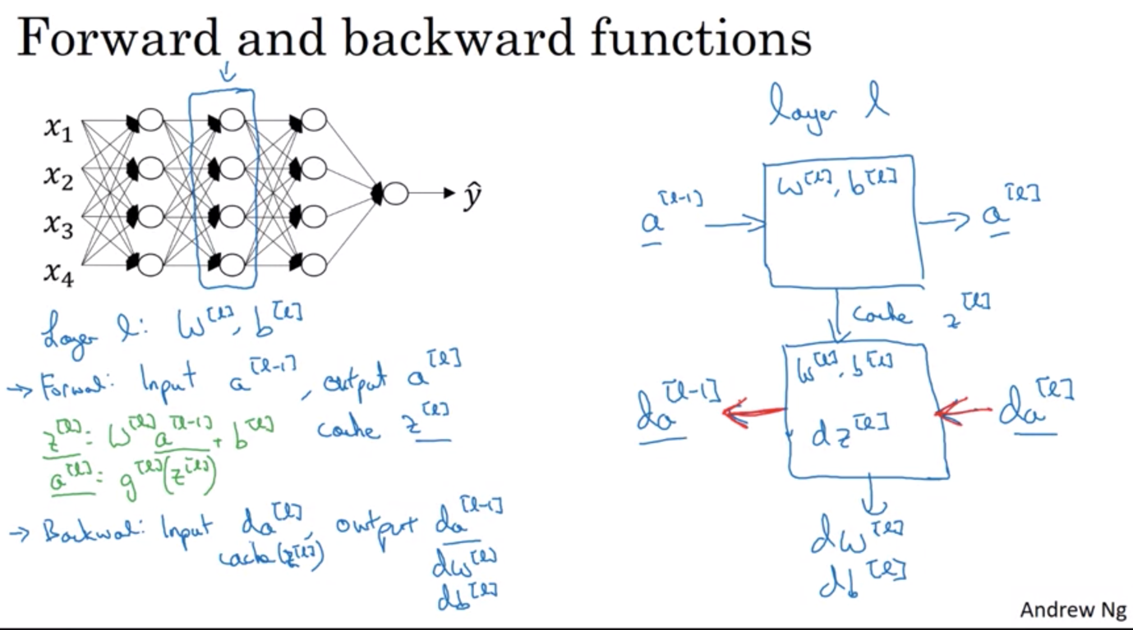

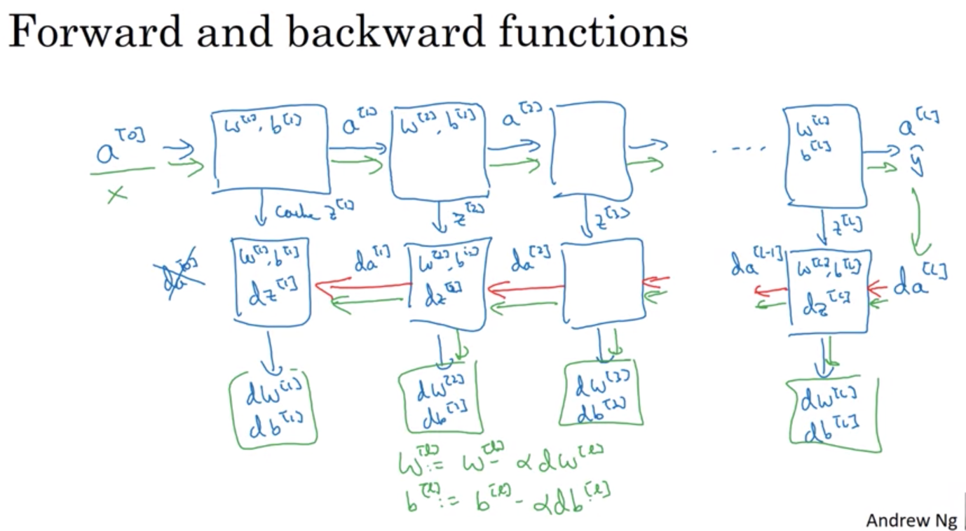

Forward and Backward Propagation

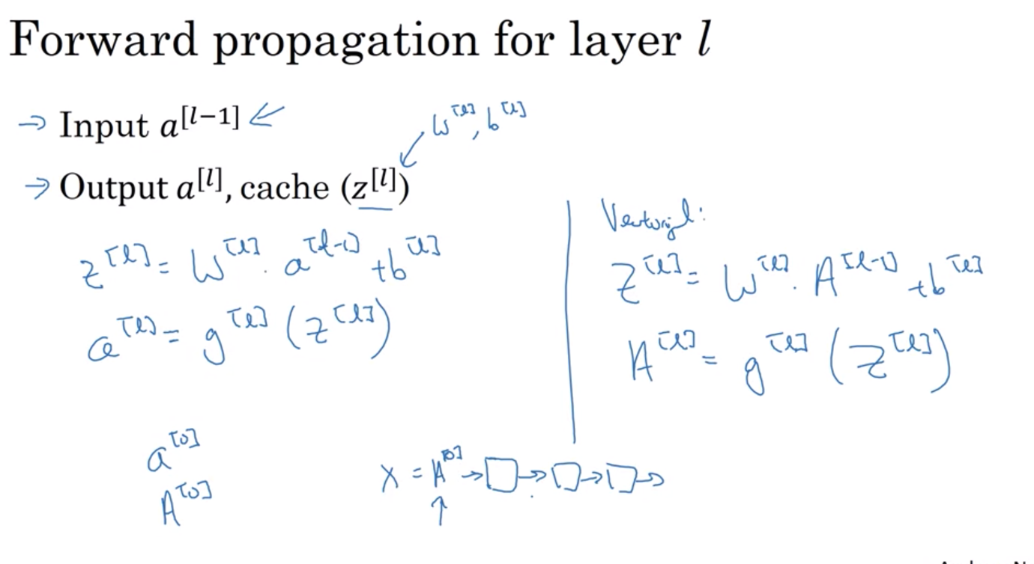

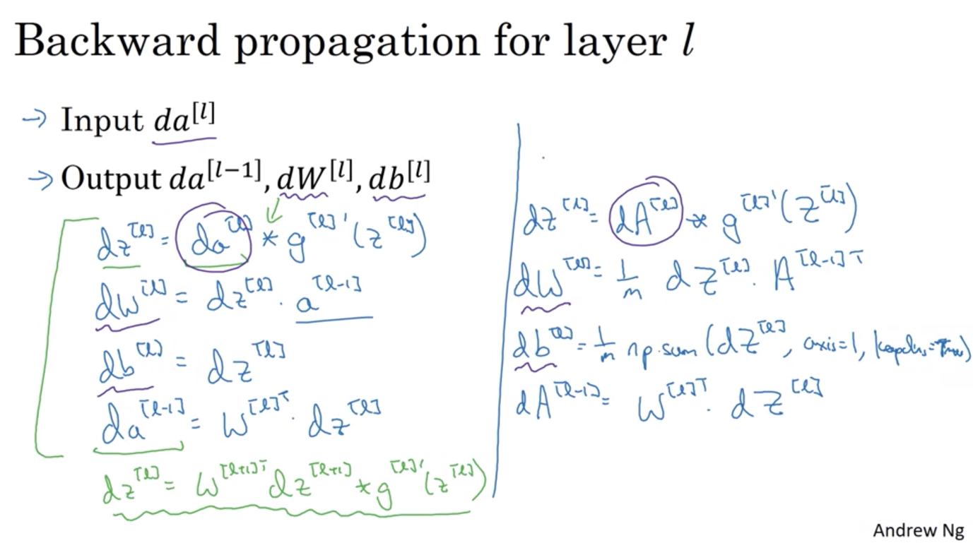

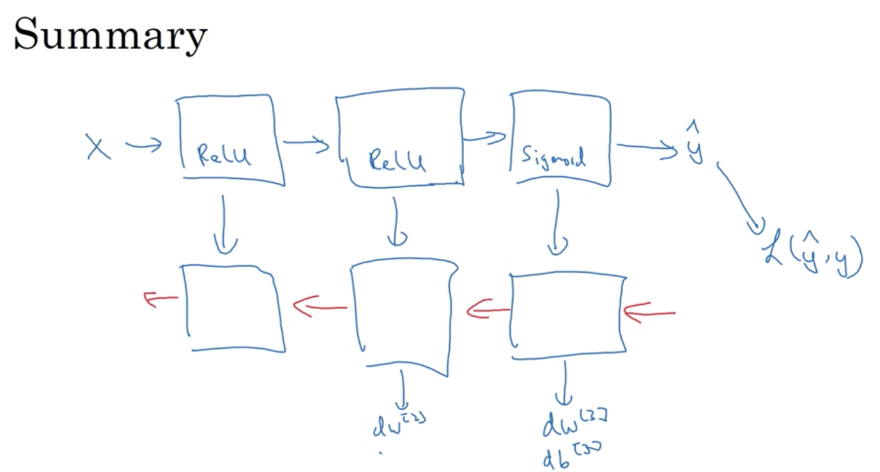

Parameters and Hyperparameters

Hyperparameters determine how parameters will be

* How to systematically check hyperparameters => 2nd course

